SUBCOURSE EDITION
IT 0306 A

US ARMY INTELLIGENCE CENTER

BORDER COORDINATES



BORDER COORDINATES

Subcourse Number IT 0306

EDITION A

US ARMY INTELLIGENCE CENTER
FORT HUACHUCA, AZ 85613-6000

4 Credit Hours

Edition Date: MAY 1995

SUBCOURSE OVERVIEW

This subcourse is designed to help you in the construction of a DF plotting facility by explaining how to use border coordinate tables. When you have finished this subcourse you will know how to get and use border coordinate tables for your own plotting facility. Map GT5a and border coordinate tables are supplied with this course. A working surface, masking tape, a very long straight edge, three different colored pens and paper will be needed for the successful completion of this subcourse. All materials should be retained until you are notified of the successful completion of the subcourse.

There are no prerequisites for this subcourse, however it is assumed you have already finished a comprehensive map reading course.

This subcourse reflects the doctrine which was current at the time it was prepared. In your own work situation, always refer to the latest official publications.

Unless otherwise stated, the masculine gender of singular pronouns is used to refer to both men and women.

TERMINAL LEARNING OBJECTIVE

ACTION: You will request and read border coordinate tables for the map you wish to use in constructing your DF plotting facility, and identify the materials required for the DF plotting facility.

CONDITION: You will use the information provided in this subcourse.

STANDARD: To demonstrate competency of this task, you must achieve a minimum of 70% on the subcourse examination.

i IT 0306

TABLE OF CONTENTS

Section Page

Subcourse Overview

Lesson 1: Explanation 1-1
Introduction 1-1

Lesson 2: Practice Exercise 2-1

IT 0306 ii

LESSON 1

EXPLANATION

Critical Task: 301-794-1307

OVERVIEW

LESSON DESCRIPTION:

Upon completion of this lesson you will be able to show your ability to request and read border coordinate tables for the map you wish to use in constructing your DF plotting facility.

TERMINAL LEARNING OBJECTIVE:

ACTION: Request and read border coordinate tables for the map you wish to use in constructing your DF facility.

CONDITION: Given the information and materials provided in this subcourse. A working surface, masking tape, a very long straight edge, three different colored pens and paper will be needed as additional materials.

STANDARD: To demonstrate competency of this task, you must achieve a minimum of 70% on the subcourse examination.

INTRODUCTION

The use of border coordinate tables is considered the most accurate method of plotting DF bearings on a gnomonic projection. The ability of the plotter to use border coordinate tables directly affects the value of the strategic direction finding net.

The system of border coordinate is based on the fact that on a gnomonic projection all great circles are represented by straight lines. Therefore, a line bearing, which of course is a great circle, may be represented by a straight line drawn between an two border points on the edge of the map (See figure 1-1).

1-1 IT 0306

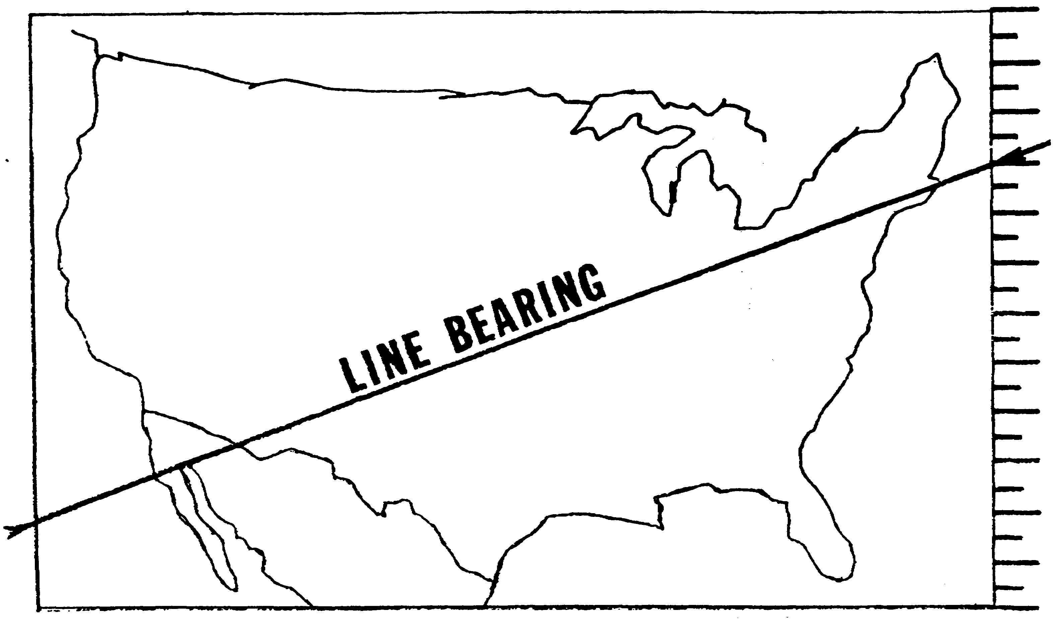

Figure 1-1. Points on edge of the map.

IT 0306 1-2

Naturally, just picking two arbitrary points doesn't do us much good, so we have to have two important items.

First, a method of identifying the particular spots on the edge of the map that are the points where the great circle path enters or leaves the map. Second, and equally important, we need to know where the DF site is which is going to report the bearing we want to identify. Let's start with identifying the border coordinates first.

Border coordinates are constructed by equally dividing the edges of a gnomonic projection into 100 major increments. These divisions are numbered clockwise from the upper left hand corner. The maps are constructed so that the divisions are numbered from 00 to 30 across the top, 30 to 50 down the right border, 50 to 80 across the bottom, and 80 to 00 (100) up the left border (See figure 1-2).

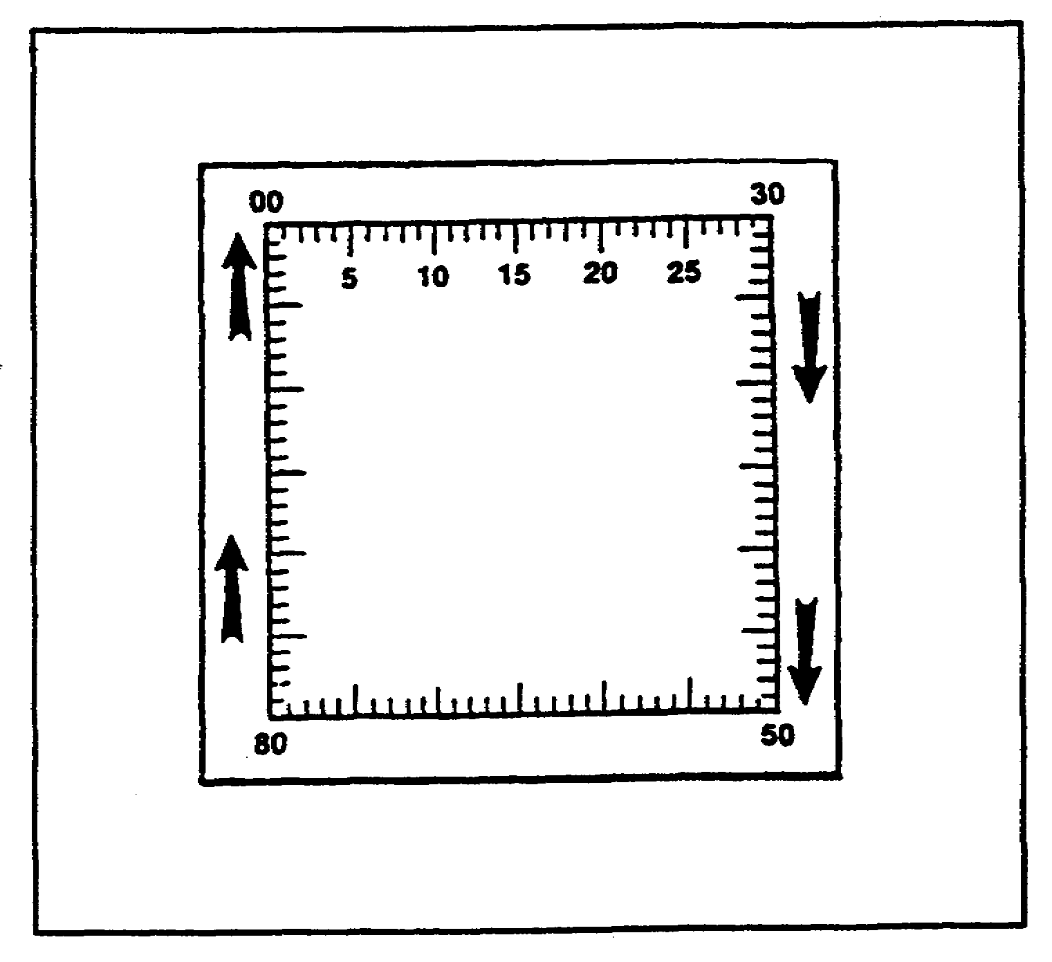

Figure 1-2. Division of numbers.

1-3 IT 0306

Each border coordinate's value in the table furnished consists of four numbers. These numbers may be located on the map edge as follows: (Refer to gnomonic projection furnished).

The first two numbers indicate the major increments, all of which are numbered form 00 to 99 clockwise around the map. Find 73 on your map.

Each major increment is divided into 10 minor increments on the map in much the same way as a ruler is divided into fractions of an inch. These minor increments are not numbered on the map, but they are indicated on the map by tick marks. The third number in the border coordinate refers to one of these tick marks. Find 733 on the map.

Each of the minor increments can be visually interpolated into tenths. If the map projection is large enough, you may even be able to find some physical means of measuring these sub-increments, such as an engineers scale or map protractor. This interpolation equates to the fourth number in the border coordinate value. Find 7332 on your map. Since there are 1000 increments (major and minor) actually indicated on the projection, this interpolation divides the edge of the map into 10,000 increments. With these 10,000 increments we can pretty well pick out any point on the edge of the map and identify it. So now we have a map of an area in which we wish to make a DF survey. First, we make sure that we are actually using a gnomonic projection, and second, we find out the exact geographic coordinates of the DF sites we wish to use. Aha! You think we've goofed! You are going to use a DF site which doesn't appear on the map! Surprise! That doesn't matter! Simply send the number of the map projection and the exact geographic coordinates of the DF site to the National Security Agency (NSA). Sit back and wait. NSA will return to you a border coordinate table for each and every DF site you listed. If the DF site does not appear on the map you will receive border coordinates for only that portion of the circle which actually falls within the map borders.

Each border coordinate table is made up of four column of figures. The first and second columns list all bearings that can be reported (0-359 for any site on the map). The third and fourth columns list the points on the edge of the map where this great circle path crosses the edge of the map. This line will always cross the DF site if the site is on the map. A straight line connecting these two values will represent the great circle path for the bearing and its reciprocal. The bearing and its reciprocal can both be found by laying the straight edge across the two points, so it should not really bother you to discover that somewhere in the course of developing the tables the column relationship reverses, so that column one and three start out equating as do two and four, while by the time the entire table is complete, columns one and four equate, as do two and three. What this means in terms of this lesson is that for site A the columns for 124.5 304.5 read 6105 9999 and immediately under that is 125.0 305.0 reading 0015 6122. This should not confuse

IT 0306 1-4

you. The computer lists the lower number first despite the fact that you might not be using both coordinates for some reason. Also, the print-out does not show the initial zero in any number, so that the 00 coordinate might be one or two digits instead of four, e.g., 15 instead of 0015. As long as you use both coordinates to establish your map markings, you should have no trouble.

The advantages of the border coordinate tables should be obvious. NSA uses machine computation to develop the table and human error is almost eliminated. The disadvantages are slowness and laboriousness in converting to usable bearings. But constructing the DF plotting facility can eliminate these drawbacks! We simply use the tables once, to construct extended edge coordinates, and then forget about them! At least we forget about them until we either change maps or move a DF site.

1-5 IT 0306

LESSON 2

PRACTICE EXERCISE

Critical Tasks: 301-794-1307

OVERVIEW

LESSON DESCRIPTION:

In this lesson you will accurately place two DF sites and mark the extended edge coordinates for each site using the gnomonic projection and border coordinate tables furnished.

TERMINAL LEARNING OBJECTIVE:

ACTION: Accurately place two DF sites and mark the extended edge coordinates for each site using 'the gnomonic projection and border coordinate tables furnished.

CONDITION: You will use the information and materials provided in this subcourse, including Map GT5a and the border coordinates tables. Additionally materials needed are a working surface, masking tape, a very long straight edge, three different colored pens and paper.

STANDARD: To demonstrate competency of this task, you must achieve a minimum of 70 % on the subcourse examination.

EXERCISE

Step 1: Provide yourself with a flat surface large enough to lay the map out completely and allow at least three inches of working space on all sides. This means a space slightly more than 28 x 20 inches.

Step 2: Cover the space with white paper, completely smooth and fasten it securely with masking tape. If you do not have a single sheet large enough to do the job, cover only the outside edges at the rectangle, do not overlap sheets of paper in the area where the map will be placed.

Step 3: Place the map in the center of the prepared area, flatten it out - if necessary, for a "really smooth" map iron it. Being extremely CAREFUL NOT TO COVER ANY NUMBER ON THE MAP, fasten the map securely with tape.

2-1 IT 0306

Step 4: Now look at your coordinate tables. The first thing you will notice is that after carefully explaining to you that the tables are arranged in four columns, we supplied you with a table bearing 12 columns. But do not be fooled. It is simply four columns arranged in sets of three. This particular set of coordinates is in half degrees. You may not need half degrees, or conversely you may want tenths. The good old computer does not care. Because of the size of map, you will be using in this lesson, for most of the lesson you will use only full degree markings.

Step 5: Gather your additional materials. You will need a straight edge at least 36 inches long, two different colored pencils - (we will assume red and blue although they do not have to be these colors), - a few thumb tacks or map tacks, a pencil sharpener, and your coordinate tables.

Step 6: At least 1 inch outside the edge of your map, draw a straight line on all four sides of the map forming a rectangle. Use the color you have chosen for your first site. We will assume it is red, but you could have used any color, as long as everything associated with the first site is the same color.

Step 7: One inch around the first rectangle, draw another, use blue (or whatever color will be associated with the second site).

Step 8: Now we have to physically locate our sites. Going back to the tables, we find site "A" has bearing coordinates of 0 and 180 degrees at 1118 and 7332. We have already located 7332, but just as a refresher, find 73, count off 3 tick marks clockwise, mentally divide the space between the third and fourth tick mark into tenths and mark off two, 7332. Simple? Do it with 1118, and check your results with figure 2-1.

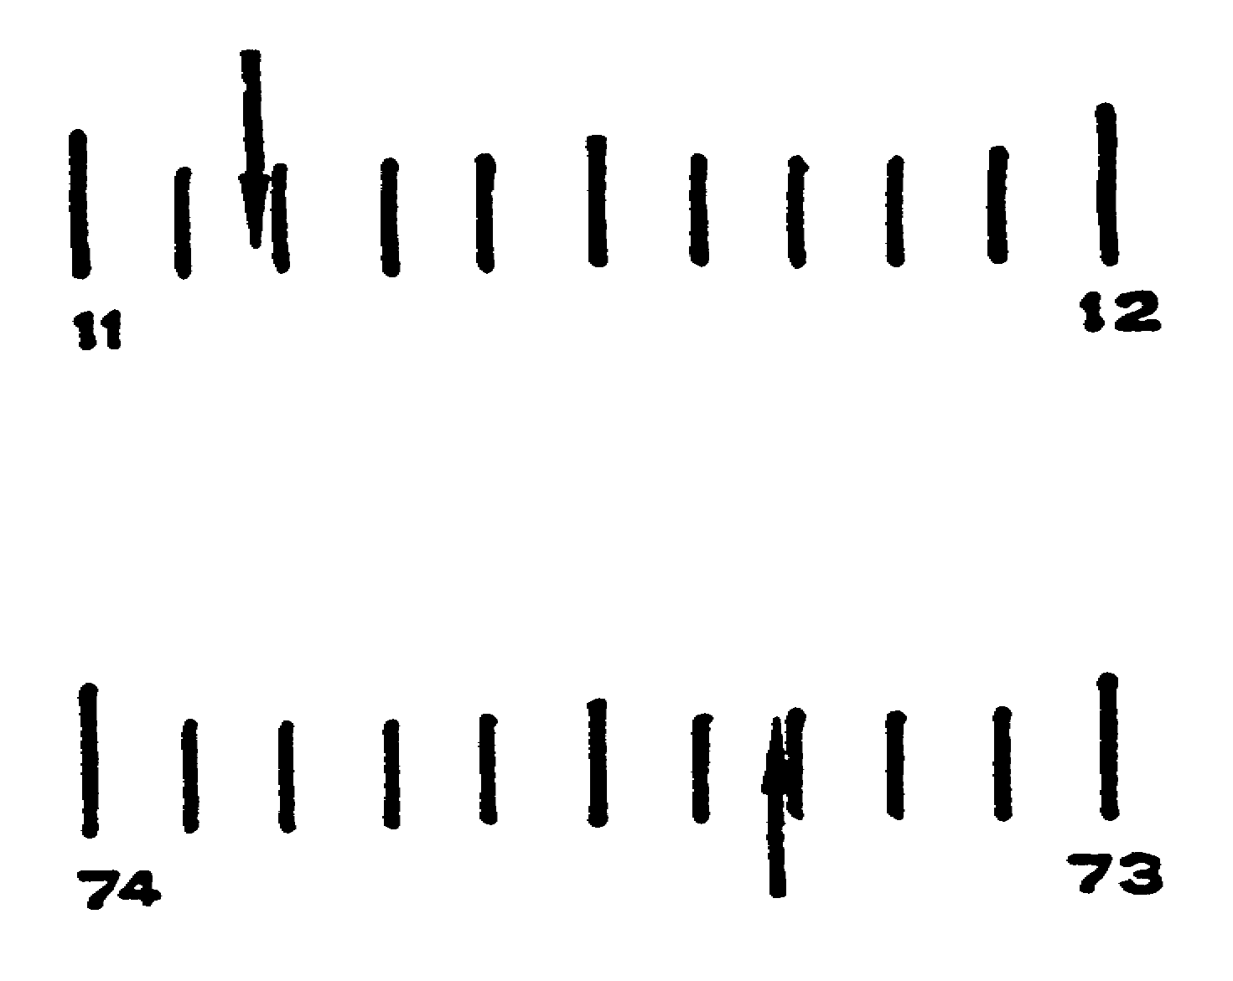

Figure 2-1. 1118 and 7332.

IT 0306 2-2

We carefully place our straight edge so that it touches both our reference points. We double check to make sure we are using the same edge of the ruler or straight edge at both ends many maps have been ruined using the wrong edge at one end. When the straight edge is aligned with both tick marks, the azimuth is laid out. The simplest, safest, and most accurate method is to hold a pencil on each edge coordinate and gently place the straight edge against both pencils. It takes four hands. Without moving the straight edge, mark a one inch line, along the edge outside the reference line for site "A" at each end. Also lightly mark the approximate locations of the site on the map (Somewhere in England). Having done this for 0-180 we now do the same thing for 90-270 using 4403 and 9240 as our reference points. Where the two lines intersect on the map is our site location. If we were marking a permanent plotting facility, we might drill a hole through the map (table and, all) at this point, so we could pass a string through it.

You should now have a map with the exact site location marked with a cross (+), and two rectangles around the map perimeter (one red, one blue ) - each one inch apart.

When producing the border coordinate scales, we will need a method of identifying the degrees. Numbering each degree line would be very difficult because of the small distance between degree lines. Therefore, we will mark each 10 degrees with a line one inch in length, each 5 degrees with a line one-half inch in length, and each degree in-between with a line one-quarter inch in length. (NOTE: If we needed to use half degree marks, we would use a line one-eighth inch in length.) Then we number only the 10 degree lines (the lines one inch in length). Put all the degree marks for each site inside the color coded rectangle that corresponds to that particular site.

If we need half-degrees, we use eighth inch lines or increase the relative sizes of the other lines if space permits. For speed in reading, we number the 10 degree markings. After we have marked the lines as far as we need, we use a colored pencil to mark each line so it is readily identifiable as belonging to that particular site.

Step 9: Mark site "A" bearings from 0 to (360) WEST to 3450 in degrees, and from 180 EAST to 1650 in half degrees. It is probably obvious to you that either type of line could be entered all the way around the map, and equally obvious that the half degree markings become difficult to read at this small a scale.

Step 10: Locate site "B" on the map (near the Adriatic Sea) and mark the reference line in degrees from 250 to 260 and in half degrees from 260 to 270 (Site "B" 0-180 1568 6349).

2-3 IT 0306

Save the map, you will need it for the examination. The remainder of the lesson concerns nice to know information. At this point, you are ready to use border coordinates in your own work.

After your map has been prepared for all the sites in your net, you may want to bring the borders into the edge of a map, hiding the edge coordinates from view. To do this, it is only necessary to put the original lines far enough from the edge of the map to enable you to put a collar around the map inside the original markings. Then replace the straight edge so that is corresponds to the marked edge coordinates and mark the collar in the same fashion as the original rectangle was marked. If this is done carefully, the new edge marking will be as accurate as the old, but the edge coordinate markings and any marginal information not needed will be out of view.

Many different methods have been devised to keep the string taunt on the plotting board, all of which can be used. Perhaps the simplest is to fasten a weight to the end of the string which passes through a hole in the map and allows the weight to dangle below the map. The other end of the string is attached to a magnet which is placed on a metal strip on the edge of the plotting board. Such things as self winding reels, pulleys, weights, cork board and tacks have been successfully used. The best string is probably a black nylon fishing line, which is small (diameter) and lightweight, also strong and relatively inexpensive. Black elastic thread may also be used, which might eliminate the need to drill holes in the board.

IT 0306 2-4

SITE A

BEARING COORDINATES BEARING COORDINATES BEARING COORDINATES

0 180 1118 7332 30 210 1785 8070 60 240 3291 8761
0.5 0.5 1127 7342 0.5 0.5 1801 8087 0.5 0.5 3311 8770
1 181 1135 7352 31 211 1817 8104 61 241 3331 8778
0.5 0.5 1144 7361 0.5 0.5 1833 8120 0.5 0.5 3350 8786
2 182 1153 7371 32 212 1849 8136 62 242 3370 8795
0.5 0.5 1162 7381 0.5 0.5 1865 8151 0.5 0.5 3389 8803
3 183 1171 7391 33 213 1882 8167 63 243 3409 8812
0.5 0.5 1180 7401 0.5 0.5 1899 8182 0.5 0.5 3428 8820
4 184 1190 7411 34 214 1917 8197 64 244 3447 8828
0.5 0.5 1199 7421 0.5 0.5 1935 8211 0.5 0.5 3466 8836
5 185 1208 7431 35 215 1953 8226 65 245 3485 8844
0.5 0.5 1217 7441 0.5 0.5 1971 8240 0.5 0.5 3504 8853
6 186 1227 7452 36 316 1990 8254 66 246 8523 8861
0.5 0.5 1236 7462 0.5 0.5 2009 8268 0.5 0.5 3541 8869
7 187 1245 7472 37 217 2029 8281 67 247 2560 8877
0.5 0.5 1255 7483 0.5 0.5 2049 8295 0.5 0.5 3579 8885
8 188 1264 7493 38 218 2069 8308 68 248 3597 8893
0.5 0.5 1274 7504 0.5 0.5 2090 8321 0.5 0.5 3616 8901
9 189 1284 7514 39 219 2111 8333 69 249 3634 8909
0.5 0.5 1293 7525 0.5 0.5 2133 8346 0.5 0.5 3653 8917
10 190 1303 7536 40 220 2155 8358 70 250 3671 8925
0.5 0.5 1313 7547 0.5 0.5 2178 8371 0.5 0.5 3690 8933
11 191 1323 7557 41 221 2201 8383 71 251 3708 8940
0.5 0.5 1333 7568 0.5 0.5 2225 8395 0.5 0.5 3726 8948
12 192 1343 7580 42 222 2250 8407 72 252 3744 8956
0.5 0.5 1353 7591 0.5 0.5 2275 8418 0.5 0.5 3763 8964
13 193 1364 7602 43 223 2300 8430 73 253 8781 8972
0.5 0.5 1374 7613 0.5 0.5 2326 8441 0.5 0.5 3799 8980
14 194 1384 7625 44 224 2353 8452 74 254 3817 8988
0.5 0.5 1395 7636 0.5 0.5 2381 8463 0.5 0.5 3835 8995
15 195 1405 7648 45 225 2409 8474 75 255 3853 9003
0.5 0.5 1416 7660 0.5 0.5 2439 8485 0.5 0.5 3871 9011
16 196 1427 7672 46 226 2469 8496 76 256 3890 9019
0.5 0.5 1438 7684 0.5 0.5 2499 8507 0.5 0.5 3908 9027
17 197 1449 7696 47 227 2531 8517 77 257 3926 9034
0.5 0.5 1460 7708 0.5 0.5 2564 8528 0.5 0.5 3944 9042
18 198 1471 7720 48 228 2598 8538 78 258 3962 9050
0.5 0.5 1483 7733 0.5 0.5 2632 8548 0.5 0.5 3980 9058
19 199 1494 7745 49 229 2668 8558 79 259 3998 9065
0.5 0.5 1506 7758 0.5 0.5 2705 8568 0.5 0.5 4016 9073

2-5 IT 0306

SITE A (continued)

BEARING COORDINATES BEARING COORDINATES BEARING COORDINATES

20 200 1517 7771 50 230 2743 8578 80 260 4034 9081
0.5 0.5 1529 7784 0.5 0.5 2783 8588 0.5 0.5 4052 9089
21 201 1541 7797 51 231 2824 8598 81 261 4070 9097
0.5 0.5 1553 7810 0.5 0.5 2866 8607 0.5 0.5 4088 9104
22 202 1566 7824 52 232 2910 8617 82 262 4107 9112
0.5 0.5 1578 7J37 0.5 0.5 2956 8626 0.5 0.5 4125 9120
23 203 1591 7851 53 233 3001 8636 83 263 4143 9128
0.5 0.5 1603 7865 0.5 0.5 3023 8645 0.5 0.5 4161 9136
24 204 1616 7879 54 234 3044 8655 84 264 4180 9144
0.5 0.5 1629 7894 0.5 0.5 3066 8664 0.5 0.5 4198 9152
25 205 1642 7908 55 235 3087 8673 85 265 4216 9159
0.5 0.5 1656 7923 0.5 0.5 3108 8682 0.5 0.5 4235 9167
26 206 1669 7938 56 236 3129 8691 86 266 4253 9157
0.5 0.5 1683 7953 0.5 0.5 3150 8700 0.5 0.5 4272 9183
27 207 1697 7968 57 237 3170 8709 87 267 4290 9191
0.5 0.5 1711 7984 0.5 0.5 3191 8718 0.5 0.5 4309 9199
28 208 1726 7999 58 238 3211 8726 88 268 4327 9207
0.5 0.5 1740 8018 0.5 0.5 3231 8735 0.5 0.5 4346 9215
29 209 1755 8035 59 239 3251 8744 89 269 4365 9224
0.5 0.5 1770 8053 0.5 0.5 3271 8752 0.5 0.5 4384 9232
90 270 4403 9240 120 300 5935 9860 150 330 599 6763
0.5 0.5 4422 9248 0.5 0.5 5955 9874 0.5 0.5 608 6773
91 271 4441 9256 121 301 5975 9889 151 331 617 6783
0.5 0.5 4460 9264 0.5 0.5 5994 9904 0.5 0.5 627 6793
92 272 4479 9273 122 302 6014 9919 152 332 636 6803
0.5 0.5 4498 9281 0.5 0.5 6032 9935 0.5 0.5 645 6813
93 273 4518 9289 123 303 6051 9950 153 333 654 6823
0.5 0.5 4537 9298 0.5 0.5 6069 9966 0.5 0.5 663 6833
94 274 4557 9306 124 304 6087 9983 154 334 672 6843
0.5 0.5 4577 9315 0.5 0.5 6105 9999 0.5 0.5 681 6852
95 275 4597 9323 125 305 15 6122 155 335 689 6862
0.5 0.5 4616 9332 0.5 0.5 31 6139 0.5 0.5 698 6872
96 276 4636 9341 126 306 46 6156 156 336 707 6881
0.5 0.5 4657 9349 0.5 0.5 61 6172 0.5 0.5 716 6891
97 277 4677 9358 127 307 76 6188 157 337 725 6901
0.5 0.5 4697 9367 0.5 0.5 90 6204 0.5 0.5 733 6910
98 278 4718 9376 128 308 105 6220 158 338 742 6920
0.5 0.5 4739 9384 0.5 0.5 119 6236 0.5 0.5 751 6929
99 279 4759 9393 129 309 133 6251 159 339 759 6939
0.5 0.5 4780 9402 0.5 0.5 147 6266 0.5 0.5 768 6948

IT 0306 2-6

SITE A - Continued

BEARING COORDINATES BEARING COORDINATES BEARING COORDINATES

100 280 4801 9412 130 310 160 6281 160 340 777 6958
0.5 0.5 4823 9421 0.5 0.5 174 6296 0.5 0.5 785 6967
101 281 4844 9430 131 311 187 6310 161 341 794 6977
0.5 0.5 4866 9439 0.5 0.5 200 6325 0.5 0.5 802 6986
102 282 4887 9449 132 312 213 6339 162 342 811 6995
0.5 0.5 4909 9458 0.5 0.5 225 6353 0.5 0.5 819 7005
103 283 4931 9468 133 313 238 6366 163 343 828 7014
0.5 0.5 4954 9477 0.5 0.5 250 6380 0.5 0.5 836 7023
104 284 4976 9487 134 314 263 6394 164 344 845 7033
0.5 0.5 4999 9497 0.5 0.5 275 6407 0.5 0.5 853 7042
105 285 5043 9506 135 315 287 6420 165 345 862 7051
0.5 0.5 5087 9516 0.5 0.5 299 6433 0.5 0.5 870 7060
106 286 5129 9526 136 316 310 6446 166 346 879 7070
0.5 0.5 5169 9537 0.5 0.5 322 6459 0.5 0.5 887 7079
107 287 5209 9547 137 317 333 6471 167 347 895 7088
0.5 0.5 5247 9557 0.5 0.5 345 6484 0.5 0.5 904 7097
108 288 5284 9568 138 318 356 6496 168 348 912 7107
0.5 0.5 5320 9578 0.5 0.5 367 6508 0.5 0.5 921 7116
109 289 5355 9589 139 319 378 6520 169 349 929 7125
0.5 0.5 5389 9600 0.5 0.5 389 6532 0.5 0.5 938 7134
110 290 5421 9611 140 320 400 6544 170 350 946 7144
0.5 0.5 5454 9622 0.5 0.5 411 6556 0.5 0.5 954 7153
111 291 5485 9633 141 321 421 6568 171 351 963 7162
0.5 0.5 5515 9644 0.5 0.5 432 6579 0.5 0.5 971 7171
112 292 5545 9655 142 322 442 6591 172 352 980 7181
0.5 0.5 5574 9667 0.5 0.5 452 6602 0.5 0.5 988 7190
113 293 5602 9679 143 323 463 6612 173 353 997 7199
0.5 0.5 5629 9690 0.5 0.5 473 6624 0.5 0.5 1005 7209
114 294 5656 9702 144 324 483 6635 174 354 1014 7218
0.5 0.5 5682 9715 0.5 0.5 493 6646 0.5 0.5 1022 7227
115 295 5708 9727 145 325 503 6657 175 355 1031 7237
0.5 0.5 5733 9739 0.5 0.5 513 6668 0.5 0.5 1039 7246
116 296 5757 9752 146 326 523 6679 176 356 1048 7256
0.5 0.5 5781 9765 0.5 0.5 532 6690 0.5 0.5 1057 7265
117 297 5804 9778 147 327 542 6700 177 357 1065 7275
0.5 0.5 5827 9791 0.5 0.5 552 6711 0.5 0.5 1074 7284
118 298 5850 9804 148 328 561 6721 178 358 1083 7294
0.5 0.5 5871 9818 0.5 0.5 571 6732 0.5 0.5 1091 7303
119 299 5893 9832 149 329 580 6742 179 359 1100 7313
0.5 0.5 5914 9846 0.5 0.5 590 6752 0.5 0.5 1109 7323

2-7 IT 0306

SITE B

BEARING COORDINATES BEARING COORDINATES BEARING COORDINATES

0 180 1568 6349 30 210 2532 6486 60 240 3874 6746
0.5 0.5 1583 6352 0.5 0.5 2551 6489 0.5 0.5 3891 6753
1 181 1598 6354 31 211 2570 6492 61 241 3908 6761
0.5 0.5 1613 6356 0.5 0.5 2590 6495 0.5 0.5 3925 6769
2 182 1628 6358 32 212 2609 6497 62 242 3941 6778
0.5 0.5 1642 6360 0.5 0.5 2629 6500 0.5 0.5 3958 6786
3 183 1657 6362 33 213 2649 6503 63 243 3974 6795
0.5 0.5 1672 6364 0.5 0.5 2670 6506 0.5 0.5 3990 6804
4 184 1678 6366 34 214 2690 6509 64 244 4006 6814
0.5 0.5 1702 6368 0.5 0.5 2711 6512 0.5 0.5 4021 6824
5 185 1717 6370 35 215 2732 6515 65 245 4037 6834
0.5 0.5 1731 6373 0.5 0.5 2753 6518 0.5 0.5 4052 6844
6 186 1746 6375 36 216 2775 6521 66 246 4068 6855
0.5 0.5 1761 6377 0.5 0.5 2797 6524 0.5 0.5 4083 6867
7 187 1776 6379 37 217 2819 6527 67 247 4098 6878
0.5 0.5 1791 6381 0.5 0.5 2841 6530 0.5 0.5 4113 6890
8 188 1806 6383 38 218 2864 6534 68 248 4128 6903
0.5 0.5 1821 6385 0.5 0.5 2886 6537 0.5 0.5 4143 6916
9 189 1836 6387 39 219 2910 6540 69 249 4157 6930
0.5 0.5 1851 6390 0.5 0.5 2933 6543 0.5 0.5 4172 6944

10 190 1866 6392 40 220 2957 6547 70 250 4168 6959
0.5 0.5 1881 6394 0.5 0.5 2981 6550 0.5 0.5 4200 6975
11 191 1897 6396 41 221 3007 6554 71 251 4214 6991
0.5 0.5 1912 6398 0.5 0.5 3038 6557 0.5 0.5 4228 7008
12 192 1927 6400 42 222 3069 6561 72 252 4242 7326
0.5 0.5 1942 6403 0.5 0.5 3098 6564 0.5 0.5 4256 7044
13 193 1958 6405 43 223 3128 6568 73 253 4270 7064
0.5 0.5 1973 6407 0.5 0.5 3156 6572 0.5 0.5 4284 7085
14 194 1989 6409 44 224 3184 6576 74 254 4297 7107
0.5 0.5 2004 6411 0.5 0.5 3212 6580 0.5 0.5 4311 7130
15 195 2020 6414 45 225 3239 6583 75 255 4325 7154
0.5 0.5 2035 6416 0.5 0.5 3265 6587 0.5 0.5 4338 7180
16 196 2051 6418 46 226 3291 6591 76 256 4351 7207
0.5 0.5 2067 6420 0.5 0.5 3317 6596 0.5 0.5 4365 7236
17 197 2083 6423 47 227 3342 6600 77 257 4378 7267
0.5 0.5 2099 6425 0.5 0.5 3366 6604 0.5 0.5 4391 7301
18 198 2115 6427 48 228 3391 6608 78 258 4404 7336
0.5 0.5 2131 6429 0.5 0.5 3414 6613 0.5 0.5 4417 7374
19 199 2147 6432 49 229 3438 6-17 79 259 4430 7415
0.5 0.5 2163 6434 0.5 0.5 3461 6622 0.5 0.5 4443 7459

IT 0306 2-8

SITE B - Continued

BEARING COORDINATES BEARING COORDINATES BEARING COORDINATES

20 000 2180 6436 50 230 3483 6627 80 260 4456 7507
0.5 0.5 2196 6439 0.5 0.5 3506 6631 0.5 0.5 4468 7559
21 201 2213 6441 51 231 3528 6636 81 261 4481 7616
0.5 3.5 2229 6443 0.5 0.5 3549 6641 0.5 0.5 4494 7679
22 202 2246 6446 52 232 3570 6646 82 262 4507 7747
0.5 0.5 2263 6448 0.5 0.5 3591 6652 0.5 0.5 4519 7823
23 203 2280 6451 53 233 3612 6657 83 263 4532 7907
0.5 0.5 2297 6453 0.5 0.5 3632 6662 0.5 0.5 4544 8000
24 204 2314 6455 54 234 3652 6668 84 264 4557 8015
0.5 0.5 2332 6458 0.5 0.5 3672 6673 0.5 0.5 4569 8030
25 205 2349 6460 55 235 3692 6679 85 265 4582 8045
0.5 0.5 2367 6463 0.5 0.5 3711 6685 0.5 0.5 4594 8060
26 206 2384 6465 56 236 3730 6691 86 266 4607 8075
0.5 0.5 2402 6468 0.5 0.5 3749 6697 0.5 0.5 4619 8090
27 207 2420 6471 57 237 3767 6704 87 267 4631 8105
0.5 0.5 2438 6473 0.5 0.5 3786 6710 0.5 0.5 4644 8120
28 208 2457 6476 58 238 3804 6717 88 268 4656 8134
0.5 0.5 2475 6478 0.5 0.5 3822 6724 0.5 0.5 4668 8149
29 209 2494 6481 59 239 3839 6731 89 269 4681 8146
0.5 0.5 2513 6484 0.5 0.5 3857 6733 0.5 0.5 4693 8179
90 270 4705 8194 120 300 5906 9149 150 330 568 6207
0.5 0.5 4718 8209 0.5 0.5 5915 9168 0.5 0.5 589 6210
91 271 4730 8223 121 301 5924 9187 151 331 609 6213
0.5 0.5 4742 8238 0.5 0.5 5933 9206 0.5 0.5 629 6216
92 272 4754 8253 122 302 5942 9225 152 332 649 6219
0.5 0.5 4766 8268 0.5 0.5 5950 9245 0.5 0.5 668 6221
93 273 4779 3282 123 303 5958 9265 153 333 688 6224
0.5 0.5 4791 8297 0.5 0.5 5966 9285 0.5 0.5 707 6230
94 274 4803 8312 124 304 5973 9305 154 334 726 6232
0.5 0.5 4815 8327 0.5 0.5 5981 9325 0.5 0.5 745 6232
95 275 4828 8341 125 305 5988 9346 155 335 764 6235
0.5 0.5 4840 8356 0.5 3.5 5995 9367 0.5 0.5 782 6238
96 276 4852 8371 126 306 6001 9388 156 336 801 6240
0.5 0.5 4865 8386 0.5 0.5 6008 9410 0.5 0.5 819 6243
97 277 4877 8401 127 307 6014 9431 157 337 837 6245
0.5 0.5 4889 3416 0.5 0.5 6021 9453 0.5 0.5 855 6248
98 278 4902 8430 128 308 6027 9475 158 338 873 6250
0.5 0.5 4914 8445 0.5 0.5 6033 9498 0.5 0.5 890 6253
99 279 4926 8460 129 309 6039 9521 159 339 908 6255
0.5 0.5 4939 8475 0.5 0.5 6044 9544 0.5 0.5 925 6258

2-9 IT 0306

SITE B - Continued

BEARING COORDINATES BEARING COORDINATES BEARING COORDINATES

100 280 4951 8490 130 310 6050 9567 160 340 942 6260
0.5 0.5 4964 8505 0.5 0.5 6055 9591 0.5 0.5 959 6263
101 281 4976 8520 131 311 6061 9615 161 341 976 6265
0.5 0.5 4989 8536 0.5 0.5 6066 9639 0.5 0.5 993 6268
102 282 5009 8551 132 312 6071 9664 162 342 1010 6270
0,5 0.5 5074 8566 0.5 0.5 6076 9689 0.5 0.5 1027 6272
103 283 5133 8581 133 313 6081 9714 163 343 1043 6275
0.5 0.5 5187 8596 0.5 0.5 6086 9740 0.5 0.5 1060 6277
104 284 5236 8612 134 314 6091 9766 164 344 1076 6279
0.5 0.5 5282 8672 0.5 0.5 6095 9793 0.5 0.5 1093 6282
105 285 5324 8643 135 315 6100 9820 165 345 1109 6284
0.5 0.5 5363 8658 0.5 0.5 6104 9847 0.5 0.5 1125 6286
106 286 5400 8674 136 316 6109 9875 166 346 1141 6289
0.5 0.5 5434 8689 0.5 0.5 6113 9903 0.5 0.5 1157 6291
107 287 5466 8705 137 317 6117 9932 167 347 1173 6293
0.5 0.5 5496 8721 0.5 0.5 6121 9962 0.5 0.5 1189 6295
108 288 5524 8737 138 318 6125 9992 168 348 1205 6298
0.5 0.5 5550 8753 0.5 0.5 20 6129 0.5 0.5 1220 6300
109 289 5575 8769 139 319 48 6133 169 349 1236 6302
0.5 0.5 5599 8785 0.5 0.5 75 6137 0.5 0.5 1251 6304

110 290 5621 8801 140 320 102 6141 170 350 1267 6307
0.5 0.5 5642 8817 0.5 0.5 129 6145 0.5 0.5 1282 6309
111 291 5662 8834 141 321 155 6149 171 351 1298 6311
0.5 0.5 5681 8850 0.5 0.5 181 6152 0.5 0.5 1313 6313
112 292 5699 8867 142 322 206 6156 172 352 1328 6315
0.5 0.5 5717 8884 0.5 0.5 231 6159 0.5 0.5 1344 6317
113 293 5733 8900 143 323 256 6163 173 353 1359 6320
0.5 0.5 5749 8917 0.5 0.5 280 6166 0.5 0.5 1374 6322
114 294 5764 8934 144 324 304 6170 174 354 1389 6324
0.5 0.5 5779 8951 0.5 0.5 327 6173 0.5 0.5 1404 6326
115 295 5793 8969 145 325 351 6176 175 344 1419 6328
0.5 0.5 5806 8986 0.5 0.5 374 6180 0.5 0.5 1434 6330
116 296 5819 9003 146 326 396 6183 176 356 1449 6332
0.5 0.5 5831 9021 0.5 0.5 419 6186 0.5 0.5 1464 6335
117 297 5843 9038 147 327 441 6189 177 357 1479 6337
0.5 0.5 5885 9057 0.5 0.5 463 6192 0.5 0.5 1494 6339
118 298 5866 9057 148 328 484 6195 178 358 1509 6341
0.5 0.5 5876 9093 0.5 0.5 506 6198 0.5 0.5 1524 6343
119 299 5887 9112 149 329 527 6201 179 359 1539 6345
0.5 0.5 5897 9130 0.5 0.5 548 6204 0.5 0.5 1553 6347

IT 0306 2-10

SITE C

BEARING COORDINATES BEARING COORDINATES BEARING COORDINATES

0 180 1859 5716 30 210 2764 5883 60 240 4009 6142
0.5 0.5 1874 5718 0.5 0.5 2780 3886 0.5 0.5 4021 6149
1 181 1889 5721 31 211 2797 5889 61 241 4034 6156
0.5 0.5 1904 5724 0.5 0.5 2814 5892 0.5 0.5 4046 6163
2 182 1919 1727 32 212 2831 5895 62 242 4057 6170
0.5 0.5 1933 5729 0.5 0.5 2848 5899 0.5 0.5 4069 6177
3 183 1948 5732 33 213 2866 5902 63 243 4081 6185
0.5 0.5 1963 5735 0.5 0.5 2883 5905 0.5 0.5 4092 6192
4 184 1978 5738 34 214 2901 5908 64 244 4103 6200
0.5 0.5 1993 5740 0.5 0.5 2918 5912 0.3 0.5 4114 6208
5 185 2007 5743 35 215 2936 5915 65 245 4125 6217
0.5 0.5 2022 5746 0.5 0.5 2954 5918 0.5 0.5 4136 6225
6 186 2037 5748 36 216 2972 5922 66 246 4147 6234
0.5 0.5 2051 5751 0.5 0.5 2990 5925 0.5 0.5 4157 6243
7 187 2066 5754 37 217 3019 5928 67 247 4167 6252
0.5 0.5 2080 5757 0.5 0.5 3058 5932 0.5 0.5 4178 6261
8 188 2095 5759 38 218 3094 5935 68 248 4188 6271
0.5 0.5 2110 5762 0.5 0.5 3130 5939 0.5 0.5 4198 6231
9 198 2124 5765 39 219 3164 5942 69 249 4208 6291
0.5 0.5 2139 5767 0.5 0.5 3198 5946 0.5 0.5 4217 6302

10 190 2153 5770 40 220 3230 5949 70 250 4227 6313
0.5 0.5 2168 5773 0.5 0.5 3261 5953 0.5 0.5 4237 6324
11 191 2183 5775 41 221 3291 5957 71 251 4246 6336
0.5 0.5 2197 5778 0.5 0.5 3220 5961 0.5 0.5 4255 6348
12 192 2212 5781 42 222 3348 5964 72 252 4265 6360
0.5 0.5 2227 5784 0.5 0.5 2276 5968 0.5 0.5 4274 6373
13 193 2241 5786 43 223 3402 5972 73 253 4283 6386
0.5 0.5 2256 5789 0.5 0.5 3428 5976 0.5 0.5 4292 6400
14 194 2270 5792 44 224 3453 5980 74 254 4301 6414
0.5 0.5 2285 5794 0.5 0.5 3477 5934 0.5 0.5 4310 6429
15 195 2300 5797 45 225 3501 5988 75 255 4318 6444
0.5 0.5 2315 5800 0.5 0.5 3524 5992 0.5 0.5 4327 6460
16 196 2329 5803 46 226 3547 5996 76 256 4335 6476
0.5 0.5 2344 5805 0.5 0.5 3569 6000 0.5 0.5 4344 6494
17 197 2359 5808 47 227 3590 6005 77 257 4352 6512
0.5 0.5 2374 5811 0.5 0.5 3611 6009 0.5 0.5 4361 6530
18 198 2389 5814 48 228 3631 6013 78 258 4369 6550
0.5 0.5 2404 5816 0.5 0.5 3651 6018 0.5 0.5 4377 6570
19 199 2419 5819 49 229 3670 6022 79 259 4385 6592
0.5 0.5 2434 5822 0.5 0.5 3689 6027 0.5 0.5 4394 6614

E-3 IT 0306

SITE C - Continued

BEARING COORDINATES BEARING COORDINATES BEARING COORDINATES

20 200 2449 5825 50 230 3708 6031 80 260 4402 6637
0.5 0.5 2464 5827 0.5 0.5 3726 6036 0.5 0.5 4410 6662
21 201 2479 5830 51 231 3744 6041 81 261 4418 6688
0.5 0.5 2494 5833 0.5 0.5 3761 6046 0.5 0.5 4425 6715
22 202 2510 5836 52 232 3778 6051 82 262 4433 6744
0.5 0.5 2525 5839 0.5 0.5 3794 6056 0.5 0.5 4441 6774
23 203 2540 5842 53 233 3811 6061 83 263 4449 6807
0.5 0.5 2556 5844 0.5 0.5 3827 6066 0.5 0.5 4456 6841
24 204 2571 5847 54 234 3842 6071 84 264 4464 6877
0.5 0.5 2587 5850 0.5 0.5 3858 6076 0.5 0.5 4472 6915
25 205 2602 5853 55 235 3873 6082 85 265 4479 6957
0.5 0.5 2618 5856 0.5 0.5 3887 6087 0.5 0.5 4487 7001
26 206 2634 5859 56 236 3902 6093 86 266 4494 7048
0.5 0.5 2650 5862 0.5 0.5 3916 6099 0.5 0.5 4502 7099
27 207 2666 5865 57 237 3930 6105 87 267 4509 7153
0.5 0.5 2682 5868 0.5 0.5 3944 6110 0.5 0.5 4516 7212
28 208 2698 5871 58 238 3957 6117 88 268 4524 7277
0.5 0.5 2714 5874 0.5 0.5 3970 6123 0.5 0.5 4531 7346
29 209 2731 5877 59 239 3983 6129 89 269 4538 7423
0.5 0.5 2747 5880 0.5 0.5 3996 6135 0.5 0.5 4546 7507
90 270 4553 7599 120 300 4976 9131 150 330 758 5512
0.5 0.5 4560 7702 0.5 0.5 4984 9152 0.5 0.5 783 5516
91 271 4567 7816 121 301 4991 9174 151 331 807 5521
0.5 0.5 4574 7944 0.5 0.5 4999 9196 0.5 0.5 831 5525
92 272 4581 8012 122 302 5017 9218 152 332 854 5530
0.5 0.5 4588 8032 0.5 0.5 5035 9240 0.5 0.5 877 5534
93 273 4595 8052 123 303 5053 9262 153 333 900 5538
0.5 0.5 4603 8072 0.5 0.5 5070 9284 0.5 0.5 922 5542
94 274 4610 8092 124 304 5086 9307 154 334 945 5546
0.5 0.5 4617 8112 0.5 0.5 5101 9330 0.5 0.5 966 5550
95 275 4624 8131 125 305 5116 9352 155 335 988 5554
0.5 0.5 4631 8151 0.5 0.5 5131 9375 0.5 0.5 1010 5558
96 276 4673 8171 126 306 5145 9399 156 336 1031 5562
0.5 0.5 4644 8191 0.5 0.5 5158 9422 0.5 0.5 1052 5566
97 277 4651 8210 127 307 5171 9446 157 337 1072 5570
0.5 0.5 4658 8230 0.5 0.5 5183 9469 0.5 0.5 1093 5574
98 278 4665 8249 128 308 5196 9493 158 338 1113 5577
0.5 0.5 4672 8269 0.5 0.5 5207 9517 0.5 0.5 1133 5581
99 279 4679 8289 129 309 5219 9542 159 339 1153 5585
0.5 0.5 4686 8308 0.5 0.5 5230 9566 0.5 0.5 1172 5588

IT 0306 E-4

SITE C - Continued

BEARING COORDINATES BEARING COORDINATES BEARING COORDINATES

100 280 4693 8328 130 310 5240 9591 160 340 1192 5592
0.5 0.5 4700 8347 0.5 0.5 5251 9616 0.5 0.5 1211 5596
101 281 4707 8367 131 311 5261 9641 161 341 1230 5599
0.5 0.5 4713 8386 0.5 0.5 5271 9667 0.5 0.5 1249 5603
102 282 4720 8406 132 312 5280 9693 162 342 1268 5606
0.5 0.5 4727 8425 0.5 0.5 5290 9719 0.5 0.5 1286 5610
103 283 4734 8445 133 313 5299 9745 163 343 1304 5613
0.5 0.5 4741 8464 0.5 0.5 5307 9772 0.5 0.5 1323 5616
104 284 4748 8484 134 314 5316 9798 164 344 1341 5620
0.5 0.5 4755 8503 0.5 0.5 5324 9826 0.5 0.5 1358 5623
105 285 4762 8523 135 315 5332 9853 165 345 1376 5626
0.5 0.5 4768 8542 0.5 0.5 5340 9881 0.5 0.5 1394 5629
106 286 4775 8562 136 316 5348 9909 166 346 1411 5633
0.5 0.5 4782 8581 0.5 0.5 5356 9937 0.5 0.5 1428 5636
107 287 4789 8601 137 317 5363 9966 167 347 1446 5639
0.5 0.5 4796 8621 0.5 0.5 5370 9995 0.5 0.5 1463 5642
108 288 4803 8640 138 318 32 5377 168 348 1480 5645
0.5 0.5 4810 8660 0.5 0.5 69 5384 0.5 0.5 1469 5648
109 289 4817 8680 139 319 106 5391 169 349 1513 5652
0.5 0.5 4824 8700 0.5 0.5 142 5398 0.5 0.5 1530 5655

110 290 4831 8719 140 320 177 5404 170 350 1546 5658
0.5 0.5 4838 8739 0.5 0.5 211 5411 0.5 0.5 1563 5661
11 291 4845 8759 141 321 245 5417 171 351 1579 5664
0.5 0.5 4852 8779 0.5 0.5 278 5423 0.5 0.5 1595 5667
112 292 4859 8799 142 322 310 5429 172 352 1611 5670
0.5 0.5 4866 8819 0.5 0.5 342 5425 0.5 0.5 1627 5673
113 293 4873 8840 143 323 373 5441 173 353 1643 5676
0.5 0.5 4880 8860 0.5 0.5 404 5446 0.5 0.5 1659 5679
114 294 4888 8880 144 324 434 5452 174 354 1675 5681
0.5 0.5 4895 8900 0.5 0.5 464 5457 0.5 0.5 1691 5684
115 295 4902 8921 145 325 493 5463 175 355 1706 5687
0.5 0.5 4909 8941 0.5 0.5 521 5468 0.5 0.5 1722 5690
116 296 4917 8962 146 326 549 5473 176 356 1737 5693
0.5 0.5 4924 8983 0.5 0.5 577 5478 0.5 0.5 1753 5696
117 297 4931 9004 147 327 604 5483 177 357 1768 5699
0.5 0.5 4939 9025 0.5 0.5 631 5488 0.5 0.5 1783 5702
118 298 4946 9046 148 328 657 5493 178 358 1799 5704
0.5 0.5 4953 9067 0.5 0.5 683 5498 0.5 0.5 1814 5707
119 299 4961 9088 149 329 708 5503 179 359 1829 5710
0.5 0.5 4968 9109 0.5 0.5 734 5507 0.5 0.5 1844 5713

E-5 IT 0306

